1. **Terraform Installed:**
2. **AWS Credentials Configured:** You should have your AWS credentials set up using the AWS CLI (aws configure) or environment variables.

**Steps:**

1. **Run the Terraform destroy command:** This command will destroy all resources that were created by your previous Terraform deployment:

**terraform destroy**

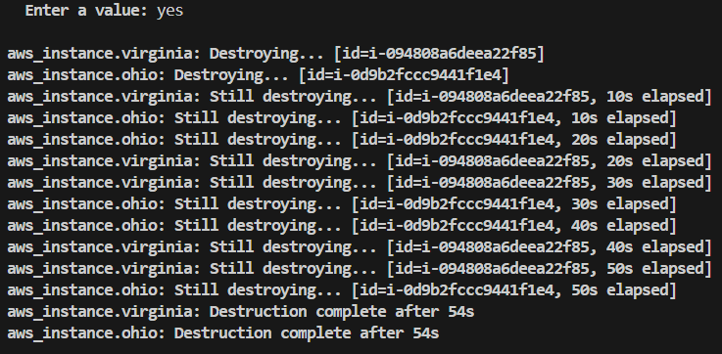

1. **Create the Terraform Configuration File:** Create a file called main.tf inside the directory with the following content:

provider "aws" {

  region = "us-east-1"

}

# Create a VPC

resource "aws_vpc" "main_vpc" {

  cidr_block = "10.0.0.0/16"

  tags = {

    Name = "main-vpc"

  }

}

# Create an Internet Gateway

resource "aws_internet_gateway" "main_igw" {

  vpc_id = aws_vpc.main_vpc.id

  tags = {

    Name = "main-igw"

  }

}

# Create a Subnet inside the VPC

resource "aws_subnet" "main_subnet" {

  vpc_id     = aws_vpc.main_vpc.id

  cidr_block = "10.0.1.0/24"

  tags = {

    Name = "main-subnet"

  }

}

# Create a Route Table

resource "aws_route_table" "main_route_table" {

  vpc_id = aws_vpc.main_vpc.id

  route {

    cidr_block = "0.0.0.0/0"

    gateway_id = aws_internet_gateway.main_igw.id

  }

  tags = {

    Name = "main-route-table"

  }

}

# Associate the Subnet with the Route Table

resource "aws_route_table_association" "main_rta" {

  subnet_id      = aws_subnet.main_subnet.id

  route_table_id = aws_route_table.main_route_table.id

}

# Create a Security Group for the EC2 instance

resource "aws_security_group" "main_sg" {

  vpc_id = aws_vpc.main_vpc.id

  # Allow inbound HTTP and SSH traffic

  ingress {

    from_port   = 80

    to_port     = 80

    protocol    = "tcp"

    cidr_blocks = ["0.0.0.0/0"]

  }

  ingress {

    from_port   = 22

    to_port     = 22

    protocol    = "tcp"

    cidr_blocks = ["0.0.0.0/0"]

  }

  # Allow all outbound traffic

  egress {

    from_port   = 0

    to_port     = 0

    protocol    = "-1"

    cidr_blocks = ["0.0.0.0/0"]

  }

  tags = {

    Name = "main-sg"

  }

}

resource "aws_instance" "virginia" {

  ami           = "ami-0e86e20dae9224db8"

  instance_type = "t2.micro"

  subnet_id          = aws_subnet.main_subnet.id

  vpc_security_group_ids = [aws_security_group.main_sg.id]

   tags = {

    Name = "hello-virginia"

  }

}

1. **Preview the Changes:** After initialization, you can preview the changes Terraform will make by running:

**terraform plan**

1. **Apply the Changes:** Apply the configuration to create the EC2 instance in the default VPC's subnet:

**terraform apply**

